CSS Manipulation using jQuery

The jQuery library includes various methods to manipulate style properties and CSS class of DOM element(s).

| **jQuery Methods** | **Description** |
| --- | --- |
| css() | Get or set style properties to the specified element(s). |
| addClass() | Add one or more class to the specified element(s). |
| hasClass() | Determine whether any of the specified elements are assigned the given CSS class. |
| removeClass() | Remove a single class, multiple classes, or all classes from the specified element(s). |
| toggleClass() | Toggles between adding/removing classes to the specified elements |

**jQuery methods changes style and css class of the DOM elements.**

[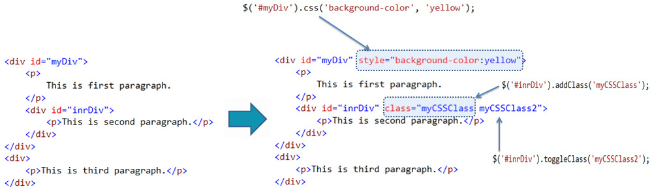](https://www.tutorialsteacher.com/Content/images/jquery/jq-css-manipulation.png)

## **jQuery css() Method**

The jQuery css() method gets or sets style properties to the specified element(s).

**Syntax:**

$('selector expression').css('style property name','value');

$('selector expression').css({

'style property name':'value',

});

Example: jQuery css() Method

$('#myDiv').css('background-color','yellow');

$('p').css({'background-color': 'red','width':'400px'});

$('#myDiv').css('background-color'); // returns rgb(255,255,0) for yellow color

**<div id="myDiv">**

**<p>This is first paragraph.</p>**

**</div>**

**<div>**

**<p>This is second paragraph.</p>**

**</div>**

**<div >**

**<p>This is third paragraph.</p> </div>**

**jQuery addClass() method**

**The jQuery addClass() method adds single or multiple css class to the specified element(s).**

**Syntax:**

**$('selector expression').addClass('css class name')**

**Example: jQuery addClass() Method**

**$('#myDiv').addClass('yellowDiv');**

**$('p').addClass('impPrg');**

**<div id="myDiv">**

**<p>**

**This is first paragraph.**

**</p>**

**</div>**

**<div>**

**<p>This is second paragraph.</p>**

**</div>**

**<div >**

**<p>This is third paragraph.</p>**

**</div>**

## **jQuery toggleClass() Method**

The jQuery toggleClass() method toggles between adding/removing classes to the specified elements.

**Syntax:**

**$('selector expression').toggleClass('css class name');**

Example: jQuery toggleClass() Method

$('#myDiv').toggleClass('redDiv');

<div id="myDiv" class="yellowDiv">

</div>